Real-Time Sign Language Conversion Using Cnn Algorithm for Disabled People

Abstract

Losing the ability to speak exerts psychological and social impacts on the affected people due to the lack of proper communication. Thus, Sign Language (SL) is considered a boon to people with hearing and speech impairment. Not each and every person can understand Sign Language. Hence, there is a need to understand sign language in verbal form with the help of converting hand gestures into sentences. Advancements in technology and machine learning techniques have led to the development of innovative approaches for gesture recognition. In this paper, a prototype is proposed to give a speech and written output for the Sign Language gestures to bridge the communication gap between people with speech impairment and normal people.
This prototype focuses on capturing the images of the hand gestures from a real-time camera and converting them into English sentences using the Machine Learning model trained using CNN Algorithm.
Keywords: Sign Language, CNN, Gesture Recognition.

Introduction

Around 70 million people in this world are mute people. There are children who suffer from Nonverbal Autism. “A system of communication using visual gestures and signs, as used by deaf people with the help of computers that automates the communication between both deaf and hearing persons using the concept of Human-Computer Interaction”. The development of Sign Language Applications for hearing impaired people is rapidly increasing due to its importance, as many of them are not able to speak and hear and not even write the spoken language. Deaf people primarily use sign language to communicate with others. Sign language uses gestures instead of sound to convey the meaning of a speaker’s thoughts. A gesture in sign language is a particular movement of the hands with a specific shape made out of them. The use of sign language puts the mute community at a disadvantage, isolating them from normal people, as they cannot communicate like everybody else. Nowadays, efficient human-computer interaction has gained a lot of importance in the framework of interactive, intelligent computing. One advancement in this direction is Sign Language Recognition. It is a technique by which sign language symbols made by the user are perceived with the help of a system. Sign language to speech converter is a prototype that converts sign language spoken by deaf & dumb communities into speech. This prototype needs to correlate different gestures into different meaningful words. Machine Learning plays a very important role in this age of Artificial Intelligence. It is used to detect patterns in data and make predictions based on those complex patterns.

System Architecture

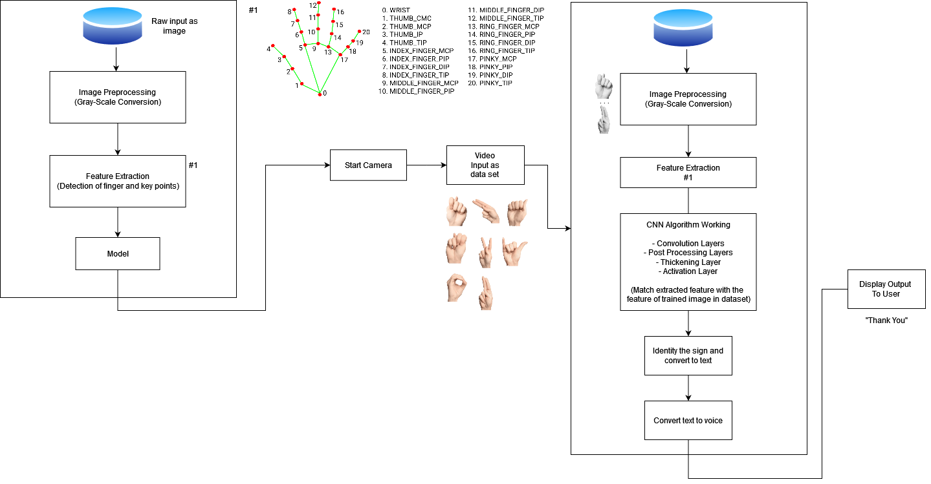

Conclusion

The aim of this paper is to help and serve the deaf of our society to communicate with normal people. Here the implementation of the system is using image-processing techniques. First, acquire an image with a camera. Then convert it to a grayscale image for further processing. CNN algorithm is used to train the model. Conversion of Sign language to English text is done and displayed and output is also generated invoice format as an added feature to the prototype.

Future Scope

Our future scope involves the application of different languages. We will try to update our system so that it won’t be limited to just the English language. We will try to bring some more international languages so that this system can be used by different people across the world.

References

[1] Sign Language Interpreter System: An alternative system for machine learning, 2021
[2] Research on Dynamic Sign Language Algorithm Based on Sign Language Trajectory and Key Frame Extraction, 2019
[3] Sign Language Recognition Using Template Matching Technique, 2020
[4] Recognition of Sign Language Symbols using Templates, 2020
[5] Multimedia technologies to teach Sign Language in a written form, 2021
[6] Wearable Sensor-Based Sign Language Recognition: A Comprehensive Review, 2020
[7] Sign Languages to Speech Conversion Prototype using the SVM Classifier, 2019

